**INFORMATICA DATA DIRECTOR**

1. **Pre-requisites :** Base Object Table , Staging Table that I have already shown in Data Modelling part.
2. **Hierarchies :** The steps to create hierarchies in MDM HUB are:

* Acquire Write lock.
* Go to Hierarchies and right click on Entity Object and select Convert BO to Entity Object and give details :

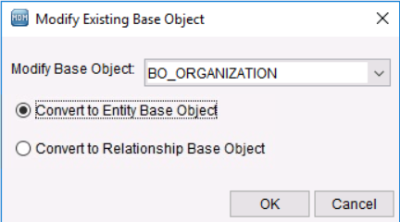

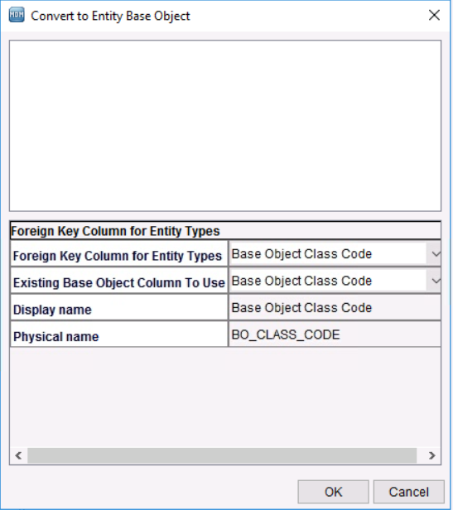

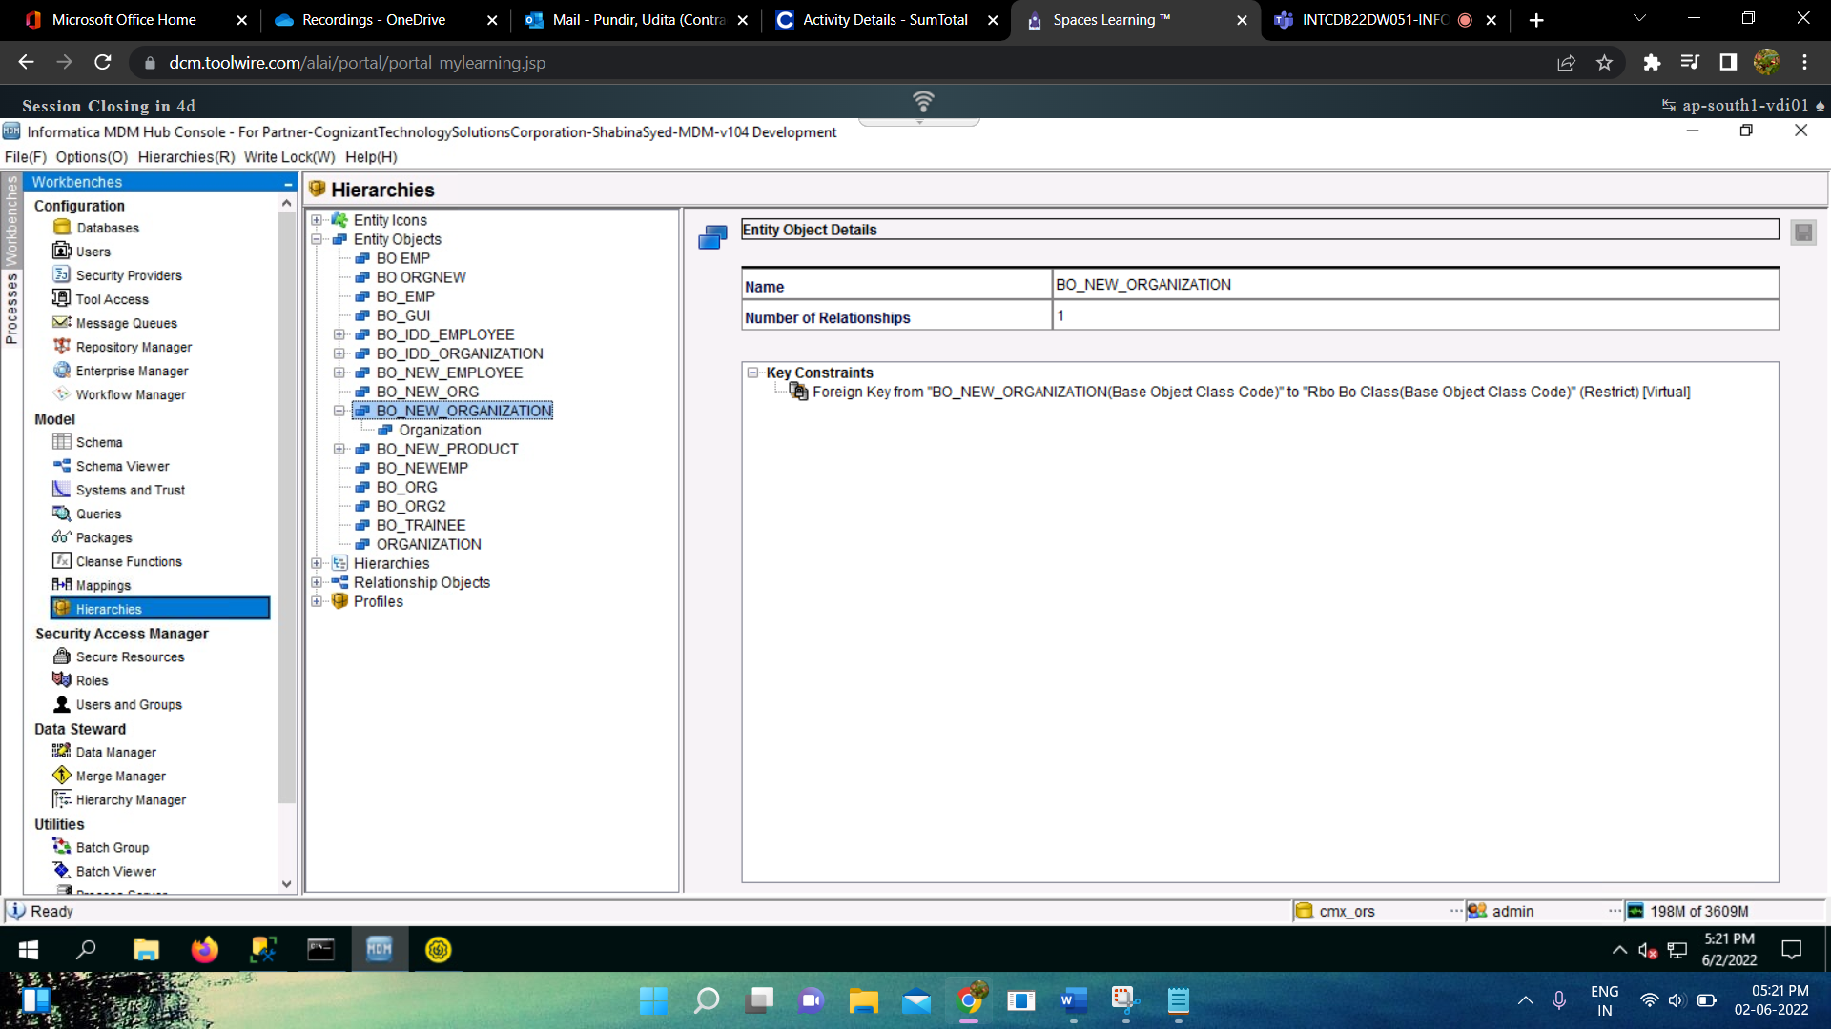

* Add Entity Type under Entity Object :

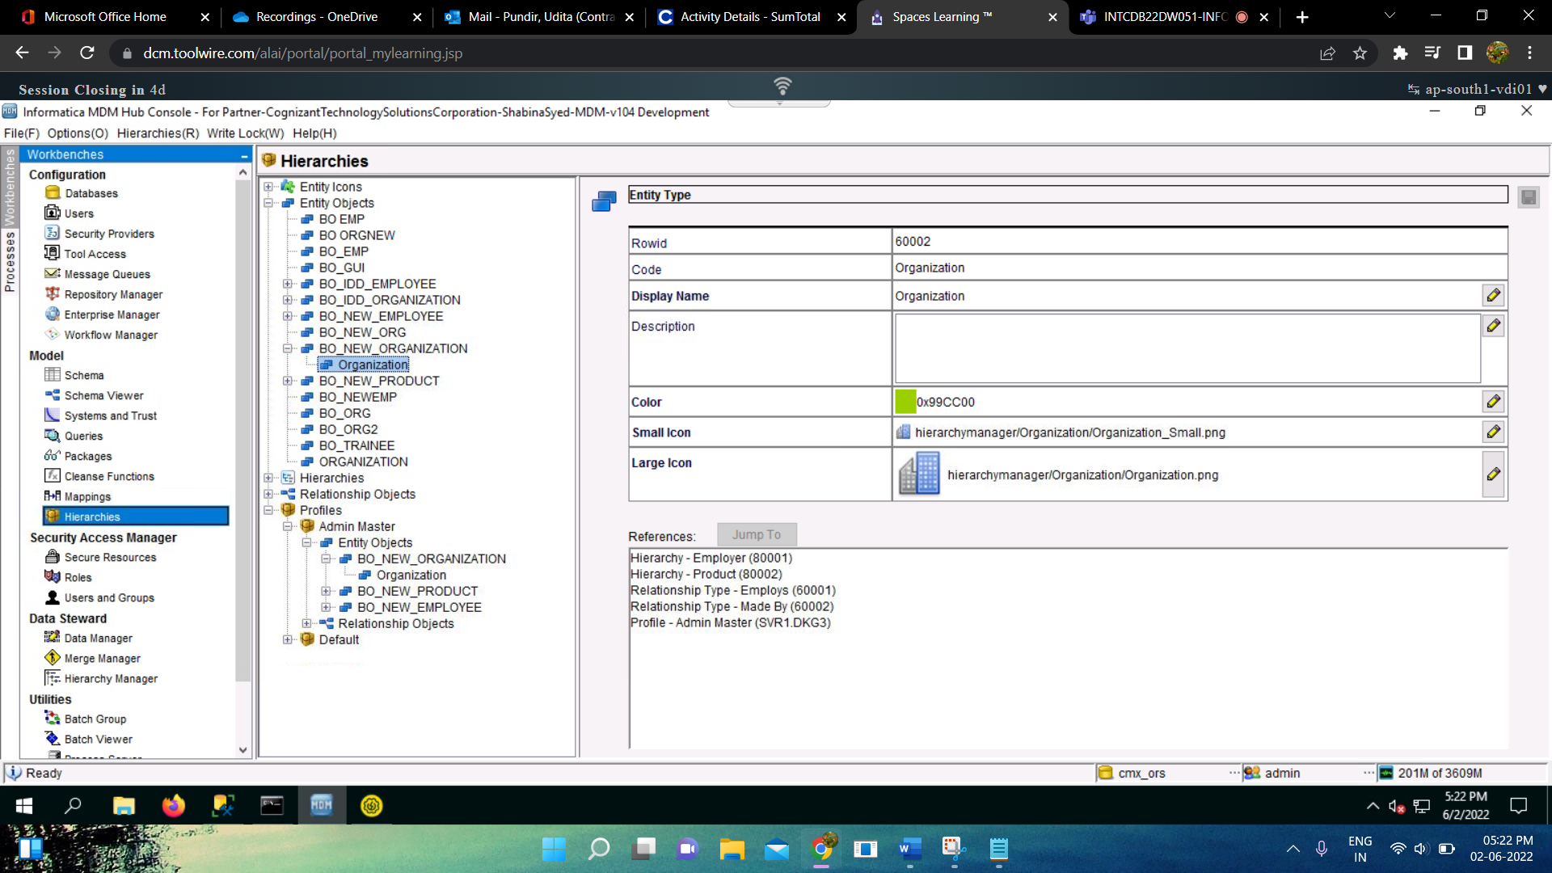

* Do the same for every entity object as per the requirement.
* After creating Entity Object and entity type, create Hierarchy:

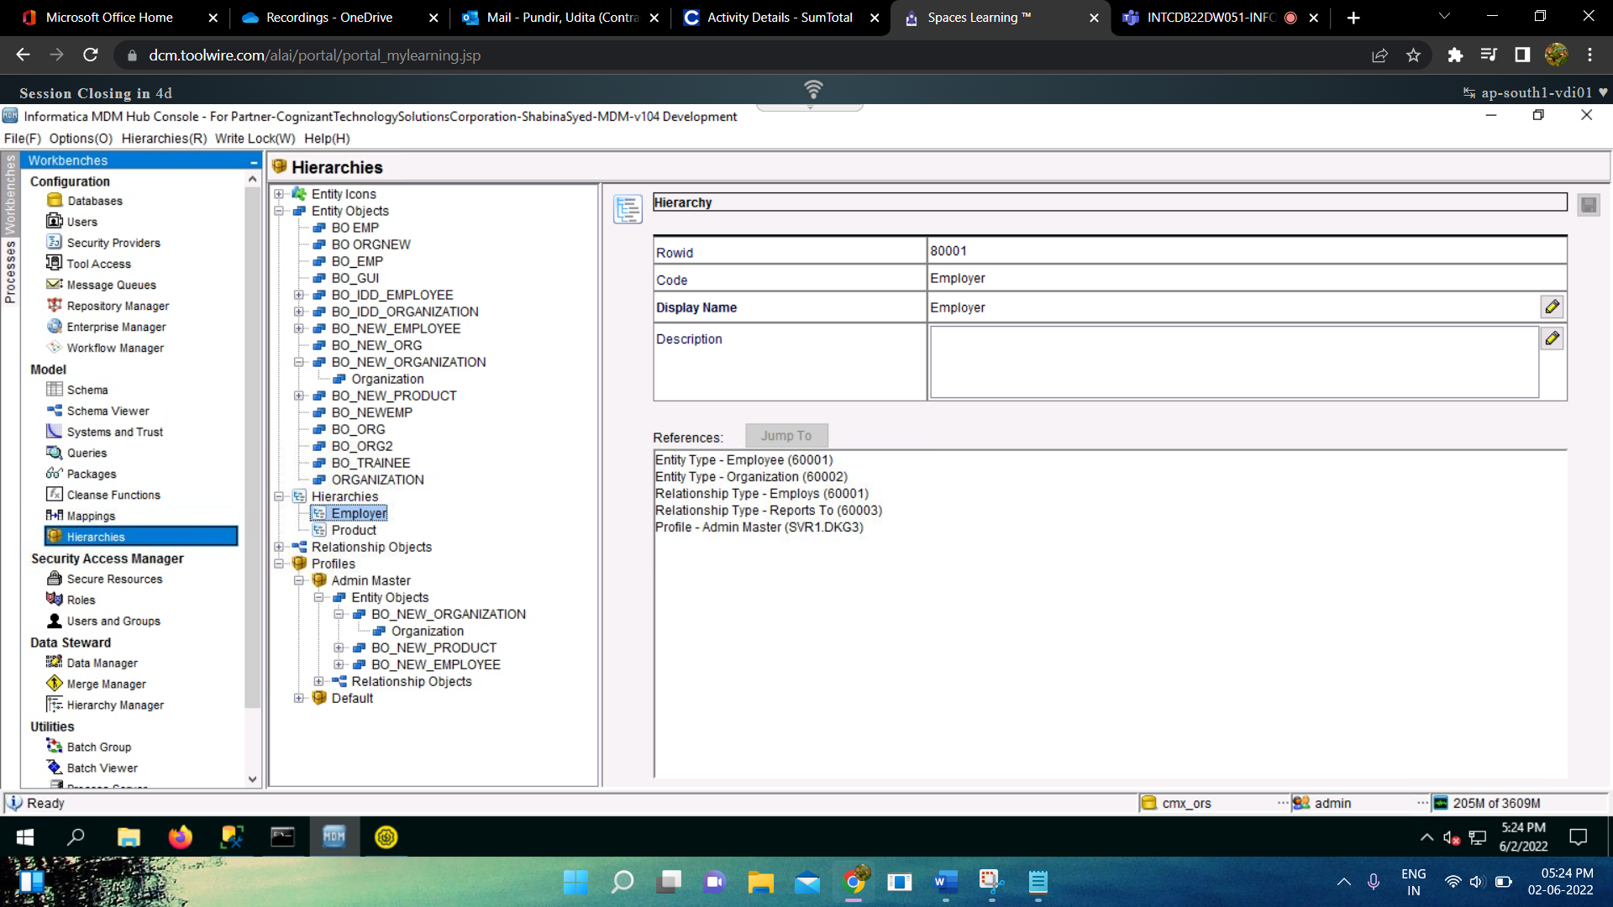

* Add relationship objects and relationship type:

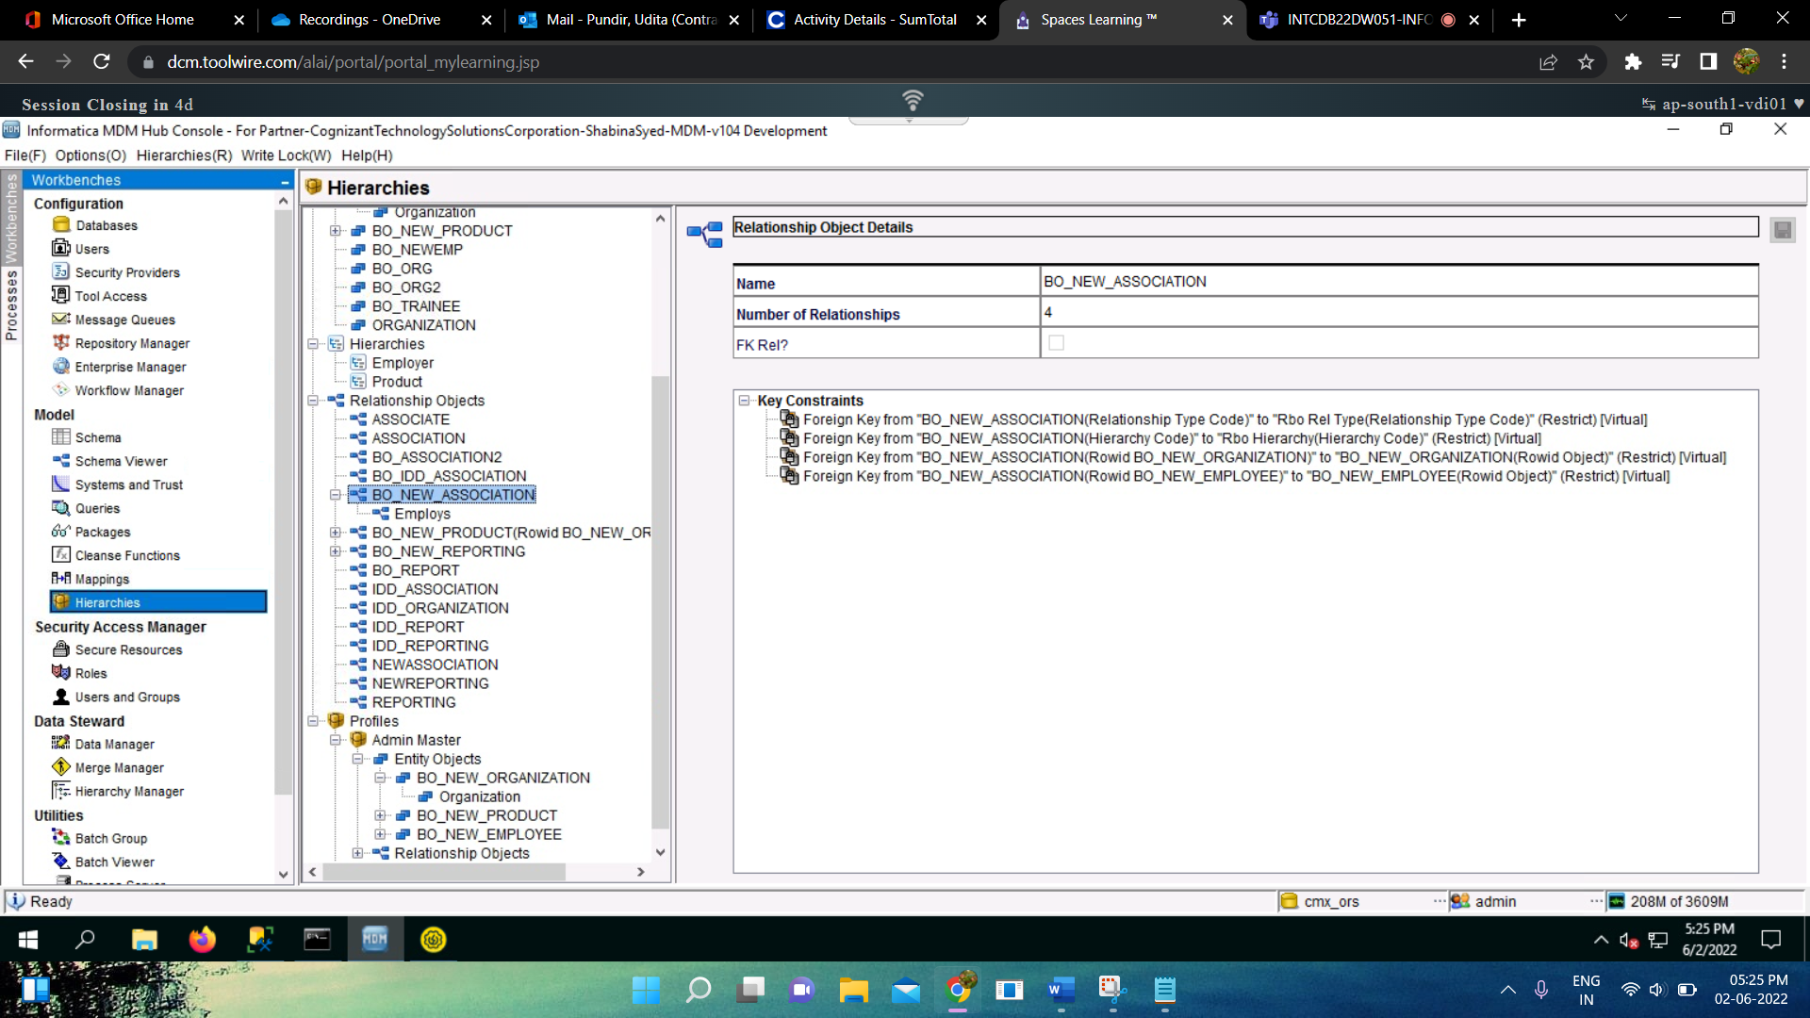

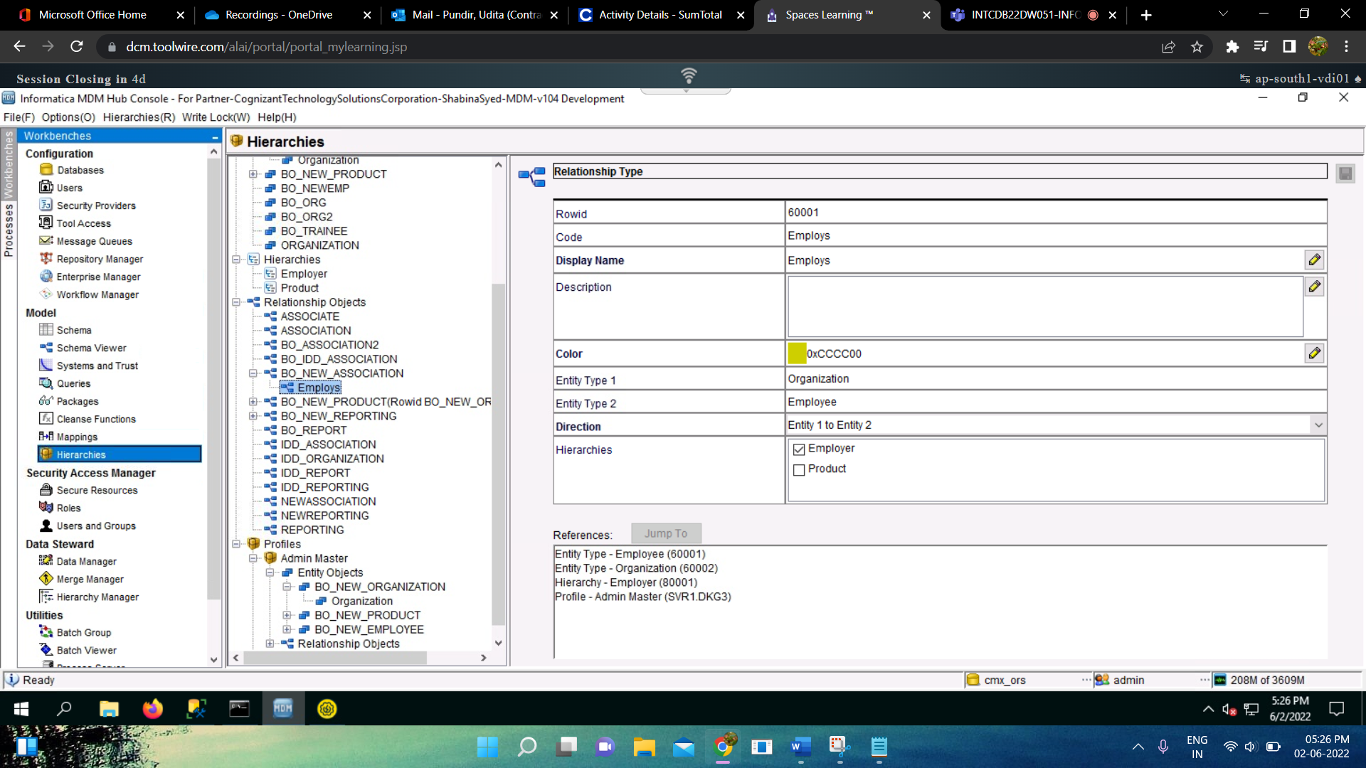

* Add profile and packages inside the entity objects and relationship type:

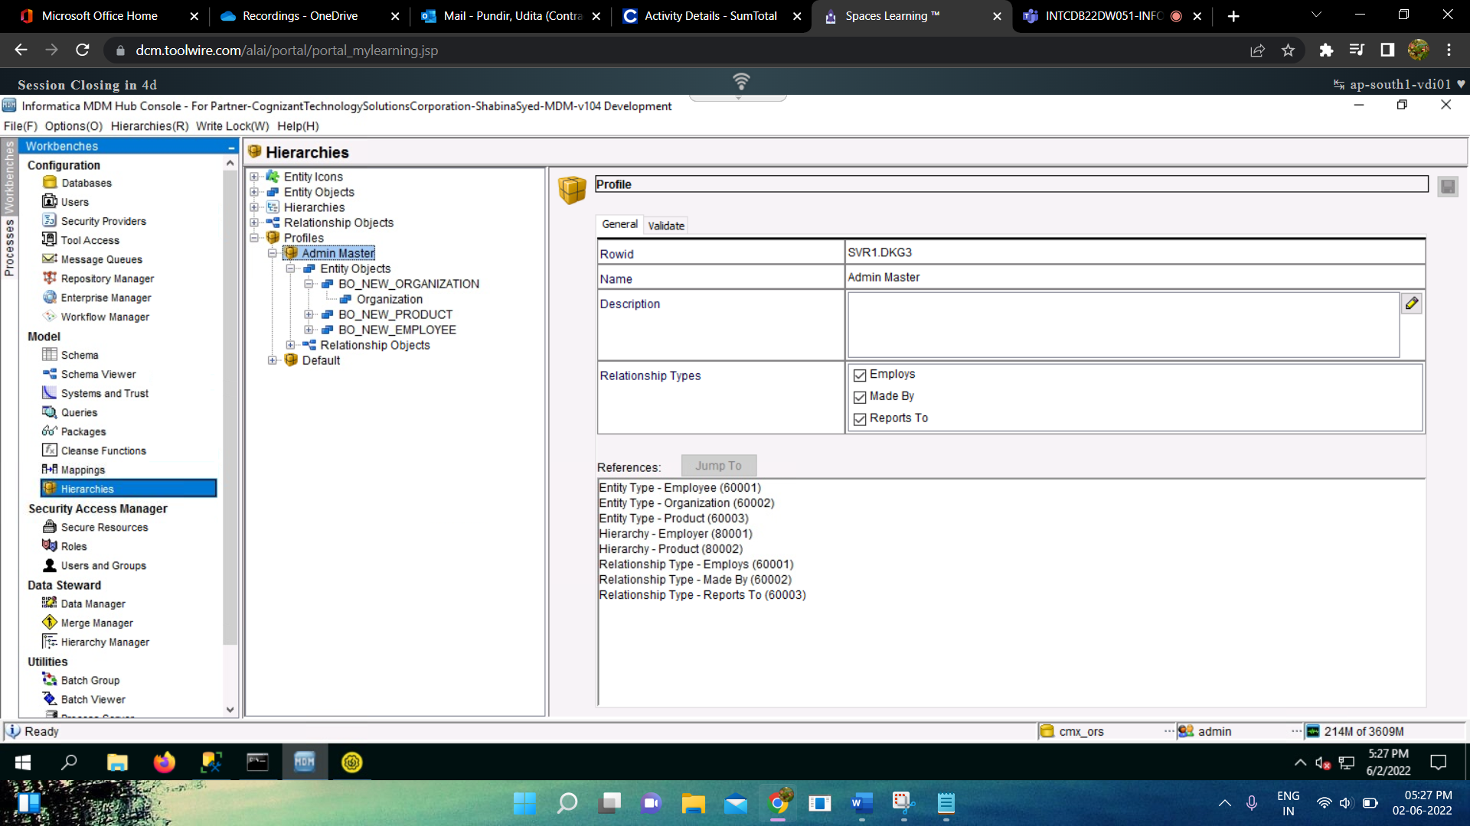

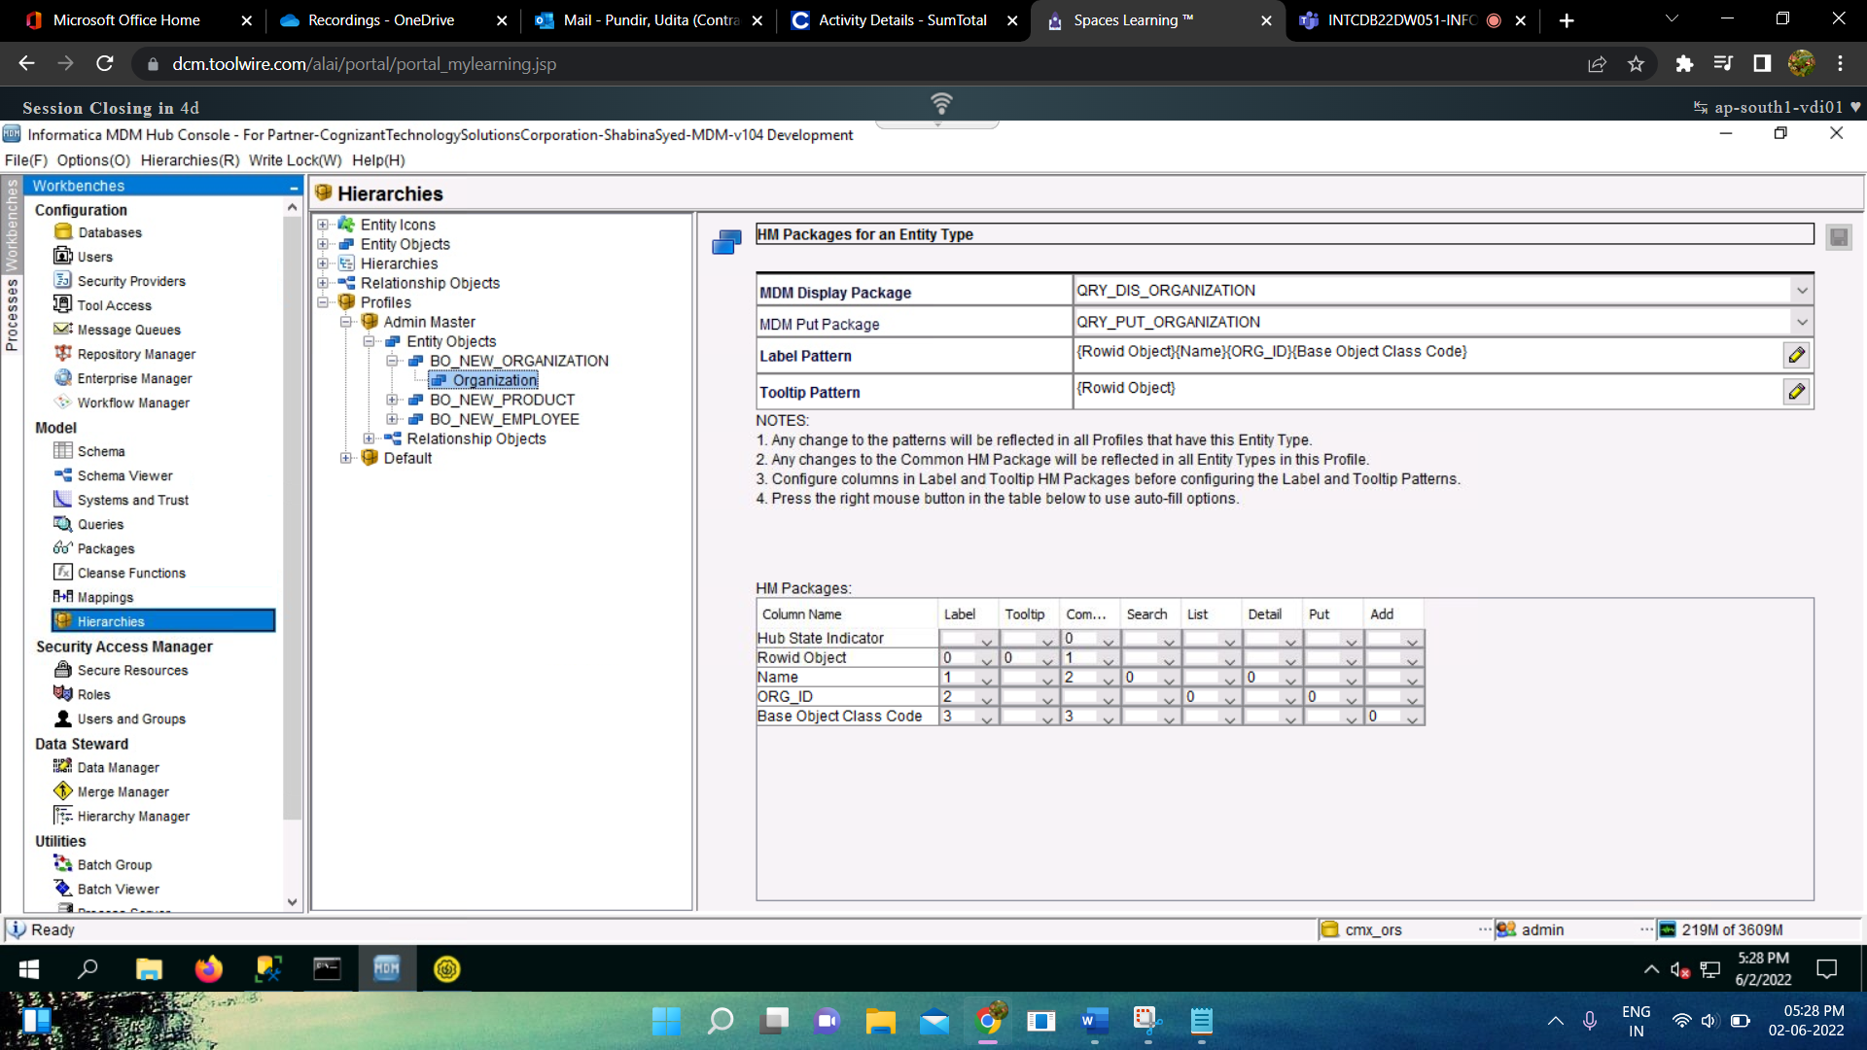

* Like this we’ll add for every entity objects and relationship type as per the requirements.

1. **IDD :** The steps to create IDD application are :
   * + Login to <http://localhost:8080/bdd/config/config_login.jsf>
     + Click on Add and give details :

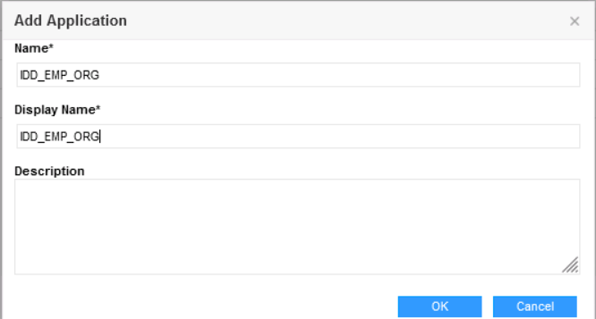

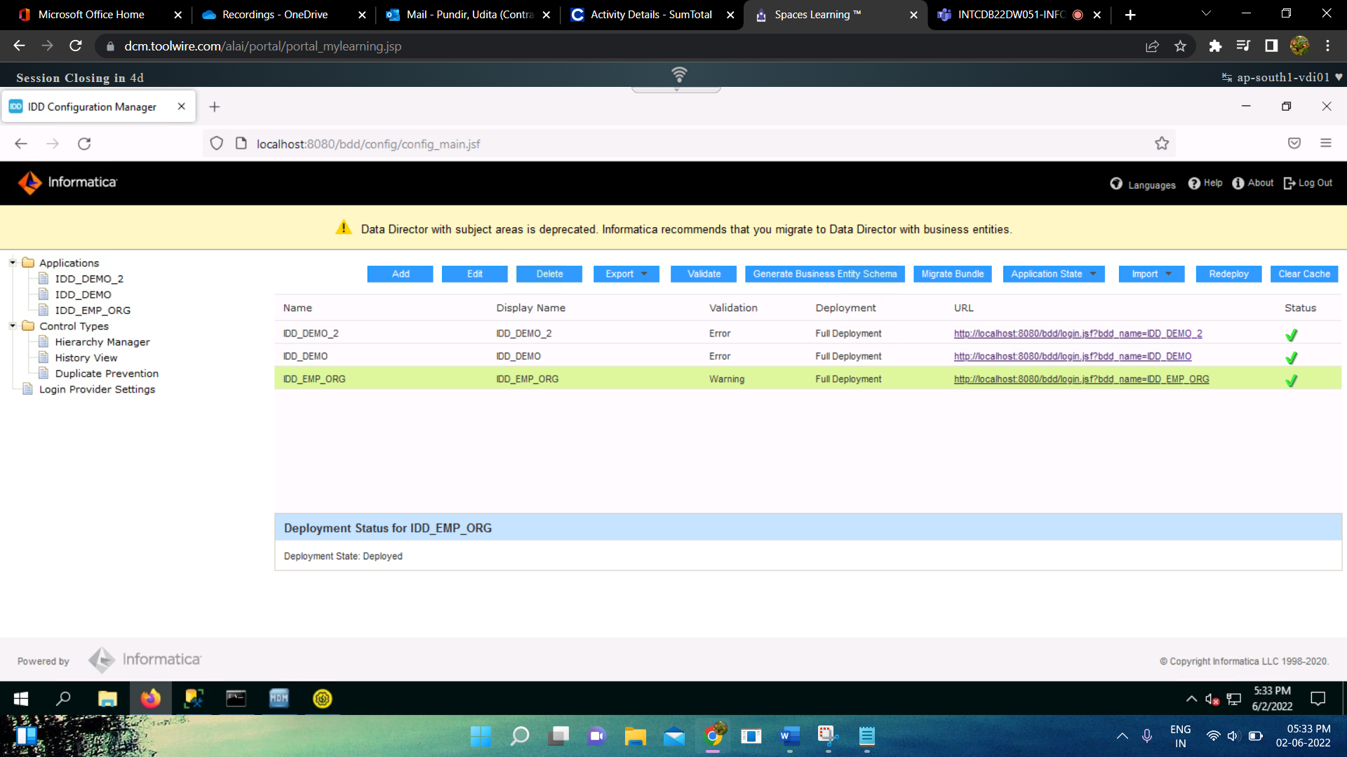

* Click on IDD_EMP_ORG under Applications in the left side and give details:

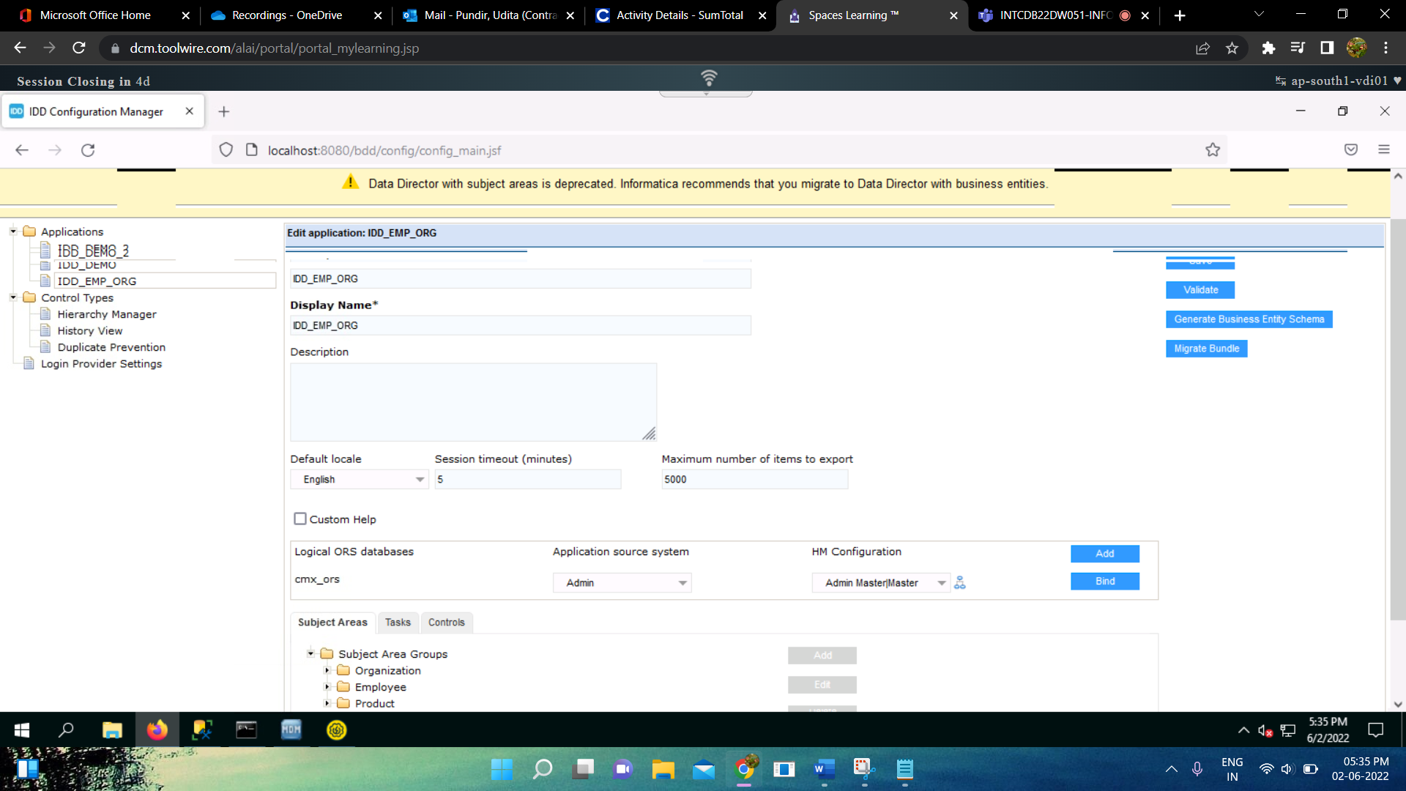

* We’ll add Subject Area and Subject Area Group :

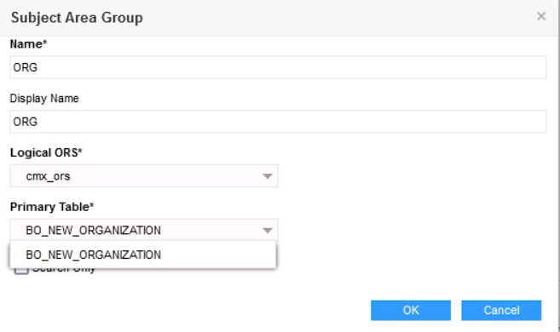

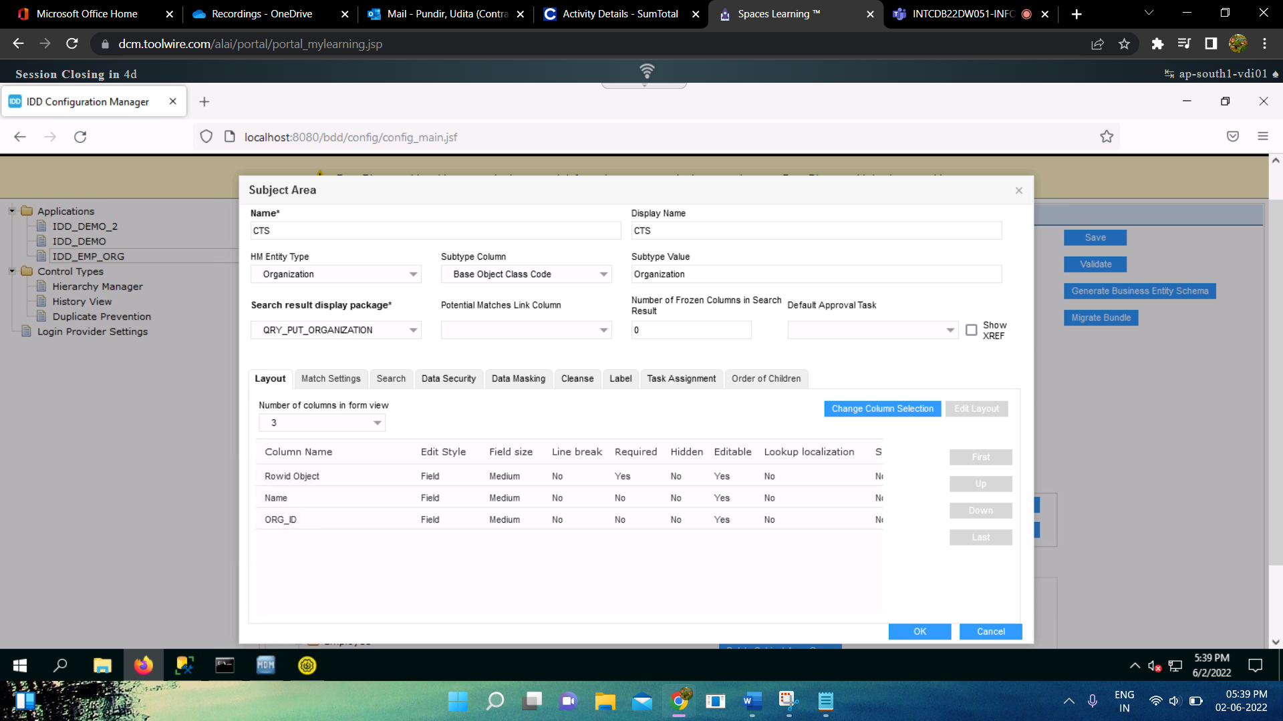

* Save and Validate and give Application State as Full deployment, Clear cache and redeploy and open the application.

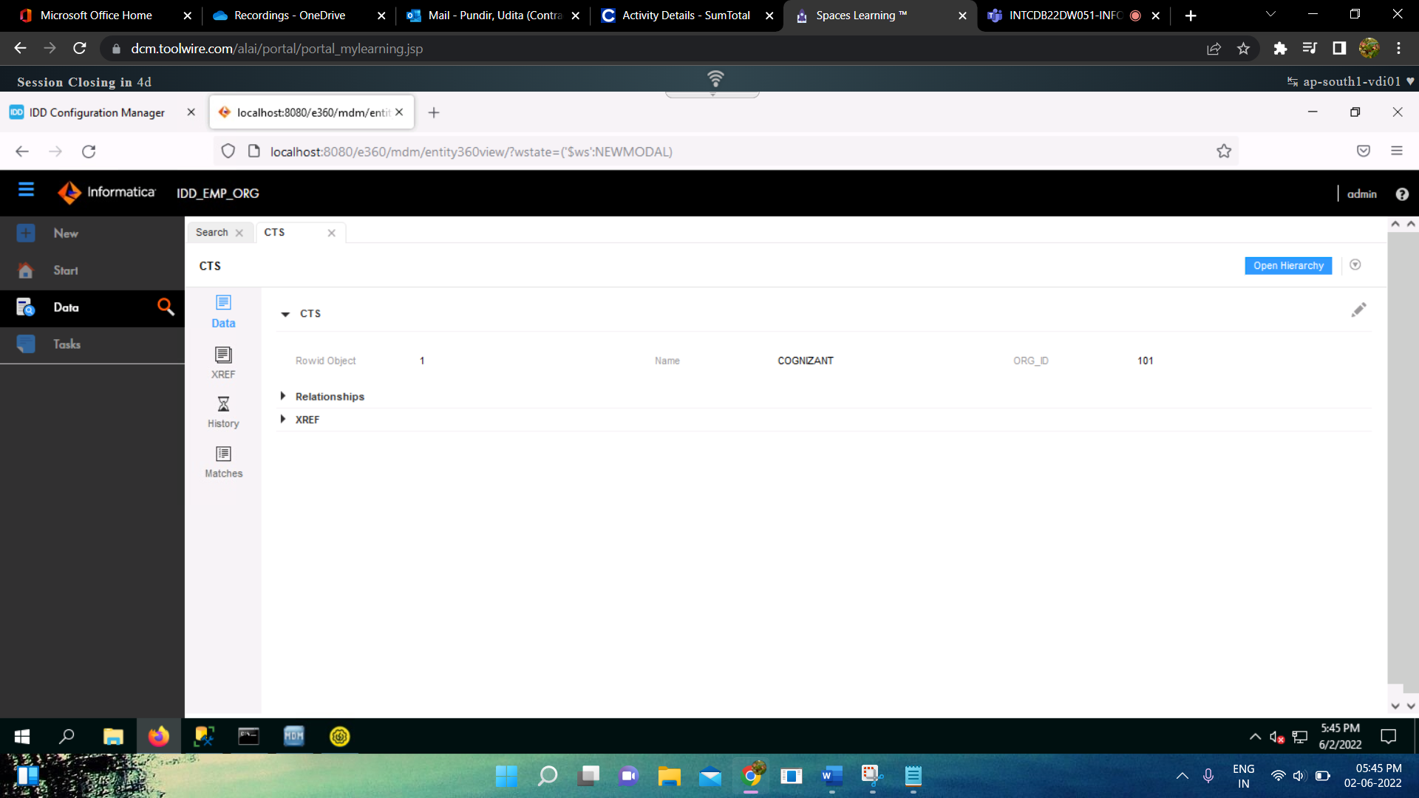

* Here, the changes can be made by the data stewards as per the requirements.